**Daria - Cake**

Intro: strum muted strings

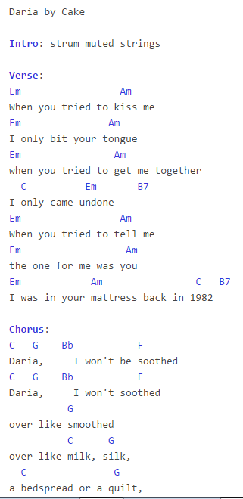

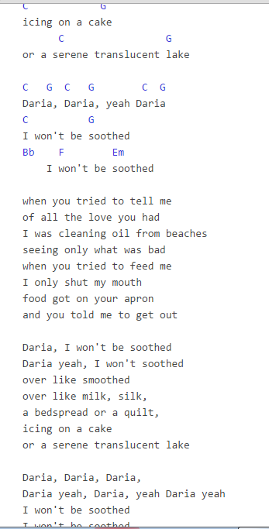

Verse:

Em Am chord diagramAmAm

When you tried to kiss me

Em chord diagramEmEm Am chord diagramAmAm

I only bit your tongue

Em chord diagramEmEm Am chord diagramAmAm

when you tried to get me together

C chord diagramCC Em chord diagramEmEm B7 chord diagramB7B7

I only came undone

Em chord diagramEmEm Am chord diagramAmAm

When you tried to tell me

Em chord diagramEmEm Am chord diagramAmAm

the one for me was you

Em chord diagramEmEm Am chord diagramAmAm C chord diagramCC B7 chord diagramB7B7

I was in your mattress back in 1982

Chorus:

C chord diagramCC G chord diagramGG Bb chord diagramBbBb F chord diagramFF

Daria, I won't be soothed

C chord diagramCC G chord diagramGG Bb chord diagramBbBb F chord diagramFF

Daria, I won't soothed

G chord diagramGG

over like smoothed

C chord diagramCC G chord diagramGG

over like milk, silk,

C chord diagramCC G chord diagramGG

a bedspread or a quilt,

C chord diagramCC G chord diagramGG

icing on a cake

C chord diagramCC G chord diagramGG

or a serene translucent lake

C chord diagramCC G chord diagramGG C chord diagramCC G chord diagramGG C chord diagramCC G chord diagramGG

Daria, Daria, yeah Daria

C chord diagramCC G chord diagramGG

I won't be soothed

Bb chord diagramBbBb F chord diagramFF Em chord diagramEmEm

I won't be soothed

when you tried to tell me

of all the love you had

I was cleaning oil from beaches

seeing only what was bad

when you tried to feed me

I only shut my mouth

food got on your apron

and you told me to get out

Daria, I won't be soothed

Daria yeah, I won't soothed

over like smoothed

over like milk, silk,

a bedspread or a quilt,

icing on a cake

or a serene translucent lake

Daria, Daria, Daria,

Daria yeah, Daria, yeah Daria yeah

I won't be soothed

I won't be soothed